Turtle for NUS
Clear head, Common sense, Cool name.
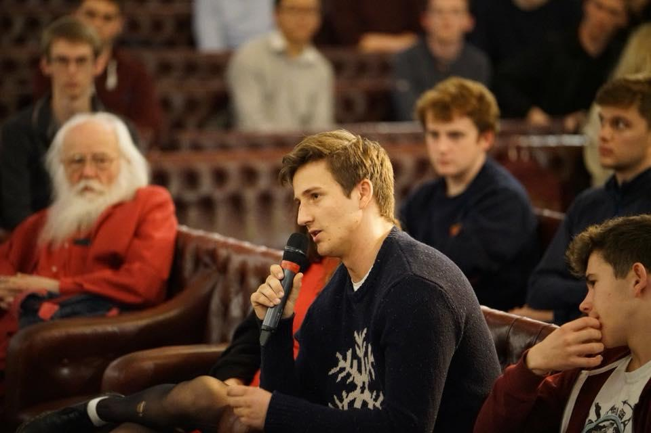
Who I Am:
I’m Tom Turtle, and I want to be your delegate at the NUS conference this spring. I am a second-year studying Politics and Anthropology at Magdalene. I currently serve as vice-chair and Social Events Officer at the Cambridge University Liberal Association.

What I Stand For:
If elected, I pledge to:
- Speak unwaveringly and unashamedly for Europe. Like the vast majority of young people in Cambridge I believe that Brexit poses a huge threat to students. I stand with you – let me speak for you.
- Help everyone achieve their dreams and build new ones at our country’s best universities. My experience applying from a rural North Wales comprehensive and doing college access work has taught me that to change the results we must change the culture.
- Keep you up-to-date and in the loop. NUS Conference is for students and about students. As such, I feel duty bound to to make it relevant for all of us.

