Sample

The survey contained 259 responses. They came from across several colleges, most notably Christ’s, Murray Edwards, Homerton, St. Catherine’s and Robinson. Similarly, there was a broad range of Subjects with the most prevalent being Natural Sciences but there are too many subjects and variations in college name entry to produce a clear chart.
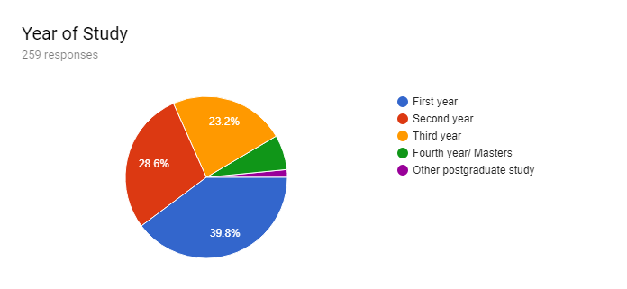

Effect of the Strikes on Students
Roughly 90% of respondents had been adversely affected by the strikes with an equally notable proportional feeling they could not attend due to pressure from picketers.
Note that the full responses shown in the graph below are as follows:
- I have missed contact hours due to cancellations by striking lecturers
- I have chosen to miss unaffected contact hours in support of striking lecturers
- I have missed contact hours as I have felt harassed/ pressured into not attending
- I did not miss any contact hours during the strikes
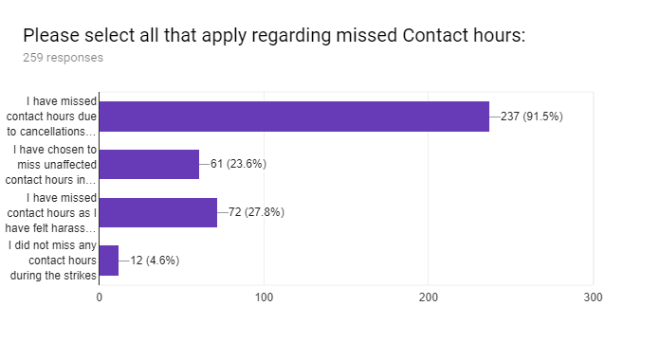
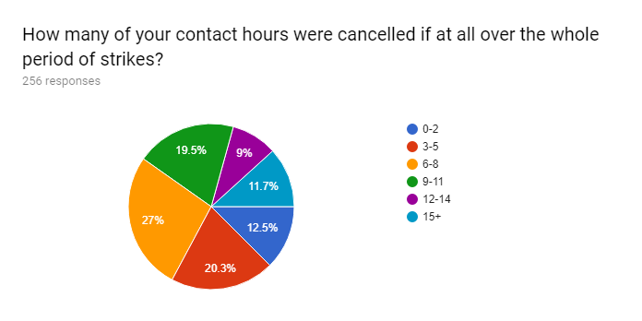
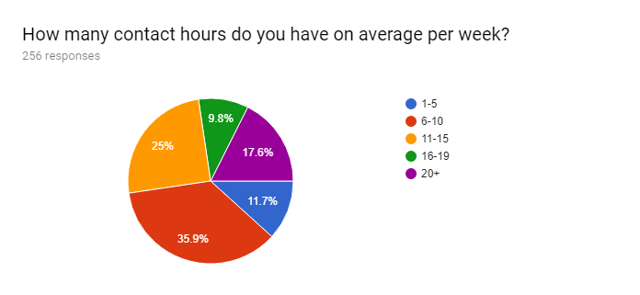
Concerningly there were very few respondents who felt that they were sure their exam performance would not be damaged:
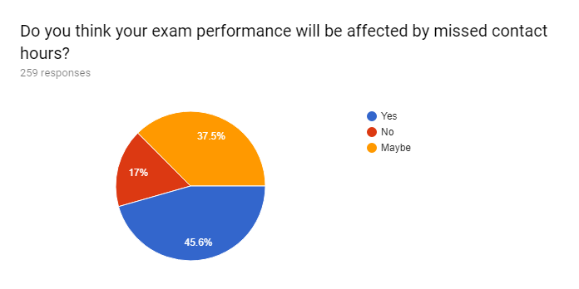

Views on Refunds
There is an overwhelming number of students who feel there should be some kind of refund with a significant split between those that feel all missed contact hours should be refunded and only cancelled contact hours should be refunded.
Of people that voted against refunds, there were several general reasons as to why summarised below:
- The cost of an education at Cambridge is actually more than the tuition fees paid each year so in the case of the strikes, the university is just subsidising less.
- To ask for a refund is to buy into the marketisation of Universities and means that students are acknowledging they are now consumers/ For us to ask for refunds while campaigning for no tuition fees we are maintaining a double standard.
- There should be more special consideration in exams/ missed content should be taught now the strikes are over.
- Students should get a flat refund regardless of how many hours they missed.
- While it would be fair, the actual value of any refund would be insignificant and so not worth pursuing.
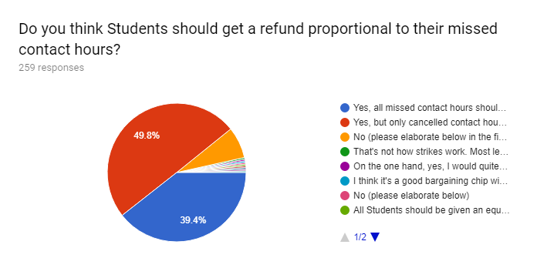
A potentially contentious issue in any negotiation with the University will be based on the fact that the UCU and the University have already agreed that money has gone into the hardship fund, so it was necessary to ascertain student opinion on the matter and whether any refunds should be sourced from elsewhere. There is no clear majority on the subject with a significant number unsure. However, the most popular option is that staff wages from the strikes should be used for refunds and not the hardship fund.
The additional responses are summarised as follows:
- The money should be used to pay overtime to any lecturers wanting to re-arrange lectures now the strikes have been called off.
- The money should be donated to local charities.
- The money should fund access events at the university.
- The money should go back to the academics who went on strike
There was also a significant response which indicated a number of students thought that staff were still paid during the strikes/ the university is reactively docking pay from them.
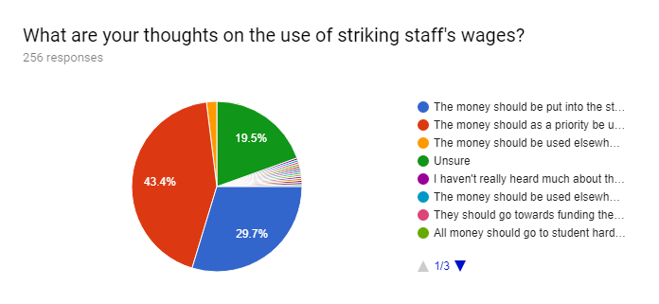

Additional Comments
The following is a summary of the responses of the final question asking for any additional comments not covered in the previous questions:
- International fees are considerably higher than domestic fees, how would this be taken in to account for any refund policy? Similarly, international students often have to pay directly for their fees rather than through a SLC so a refund would be considerably more beneficial to them. (this was by far the most common additional comment)
- The damage has now been done to students, but any resolution should be dealt with through welfare and academic support.
- CUSU’s time and effort would be much more effectively used if put towards campaign for the abolition of fees and the reinstatement of grants, and campaigns/ occupations at other institutions has been successful in securing significant additional funding for grants and bursaries
- The money should not be put into the hardship fund but added to general bursaries for students, as the hardship fund will never be exhausted and just mean that the University itself will likely put less into it over the coming years.
- Several departments are not altering exams in any way to compensate even though they did not have any lectures over those 3 weeks.
- In not paying staff the university are acknowledging a service has not been received, so students should be compensated.
- Support of refunds should not be taken as a failure of the strikes. The strikes were between the University and the lecturers, refunds are a matter between students and the University.
- Further comments on marketisation and commodification as described in Section 3
- To ask for refunds makes the University’s position more difficult, meaning that if there were to be further industrial action at a later date they may give concessions earlier as they know that students will fight for what they deserve as well as the lecturers.
- Vice-Chancellor is also over-paid and should therefore make a contribution to various funds/ pay for refunds

If you would like to see any of the raw data submitted for this survey or wish to discuss the survey in general please email vp@thejcr.co.uk

